Nathan Allen

CSCI 43700-25633

Final Project

URL

Initial Proposal:

For my final project I had the idea to make an auto chess style game like “DOTA Auto Chess” or RIOT’s “Teamfight Tactics”. These games can be very complicated with different characters and synergies, but I thought it would be interesting to make a version based on the actual game of chess.

My initial idea looks like this: Chess board on the left side of the screen. Interface on the right side that has pieces for “sale”. Every round you are given “income”. That money can be spent on a new piece or to increase your income for later in the game. To buy a piece just grab it and drop it onto the bottom row of the board where you would like it to go. After you are done buying pieces, you can move to the next round. This is where the Auto comes in. The pieces for both players make their move. When the pieces move they first see if they can capture one of the opponents pieces, and will do so if possible. If they cannot capture, the piece will move as it normally does. I am not set on how each piece will move (simple option is 1 space forward) but I want their capture moves to be similar to the way they move in a normal game of chess. As you lose pieces, you lose “lives” and better pieces are worth more, but more versatile (maybe gain lives when captured). You lose when you have 0 lives.

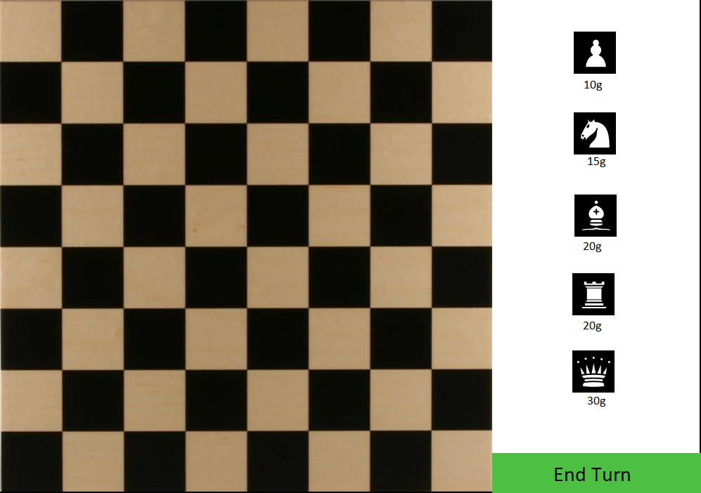

Potential ideas (wouldn’t it be cool if…):

* The biggest (and hardest) thing I would like to include is LAN multiplayer. This may be far fetched but I want to try for it.
* Fog of war such that you cannot see the opponent’s side of the board, or the first few squares.
* I know there will be a lot of pieces getting stuck on each other, and can not move or attack. I am not sure if this will need to be addressed or if the natural gameplay will fix these issues. But a solution for this may be necessary. Simple solution could be both pieces are captured and both players lose lives.
* I am programming in javascript and would be cool if I could make it operate as a mobile app as well. Andy mentioned this in a lecture.
* Different Board Sizes. The base board size may not be ideal, I will test different sizes. And maybe add different game modes with different and/or non square boards.
* Add a way to have skins for pieces/spaces/button

Game Design (working)

Main Objects

Board - Scene (main scene)

1. Holds/manages
   1. Array of Spaces
   2. Array of Pieces
   3. Player Interface

Piece - Sprite

1. Represents the chess pieces on the board and on the interface.
   1. Each piece will eventually be represented by a child object for the different kinds of pieces (how they move/capture).
2. Manipulated by player
   1. Able to be picked up and placed on the board in the desired position
3. Have different states/interactions when on the interface/on the board.
   1. Pieces can’t be clicked after they are put onto the board.
   2. Also interact different if other piece is currently in the square.

Space - Sprite

1. Used to hold pieces and handle capturing.
   1. The Pieces will control their movement, but the Spaces handles what happens after those moves.
2. Simply changes states based on coming and going pieces.

Interface - Scene

1. This where be where the “Shop” and “End Turn” button will go.
2. Interacts with the mouse different, allows player to pick up pieces to place on board.
3. This will handle the player current Money they have to buy pieces.
4. Players can buy as many pieces as they want each turn

Found that interface worked much better as a sprite and have board control the shop and next round button. It was turning into spaghetti having the pieces > shop > interface > board with passing variables..